LOAD BALANCER WITH AUTOSCALING WITH THE RULE 70-30 WEIGHTED POLICY

1.with the weighted routing we can switch the traffic between versions of your application
2.This configuration allows up to control the distribution of traffic to our application

1.create a template--nginx-tg
2.create a template--apache-tg

3.create a autoscaling group(nginx)
1.name ------ASG-nginx
2.template---nginx-lt
3.az and subnets----1a,1b,1c
4.capacity
desired-------1
minimum----1
maximum----2
5.add sns
6.tag---Name-nginx
7.create a autoscaling group

4.create a autoscaling group(apache)
1.name ------ASG-apache
2.template---apache-lt
3.az and subnets----1a,1b,1c
4.capacity
desired-------1
minimum----1
maximum----2
5.add sns
6.tag---Name-apache
7.create a autoscaling group

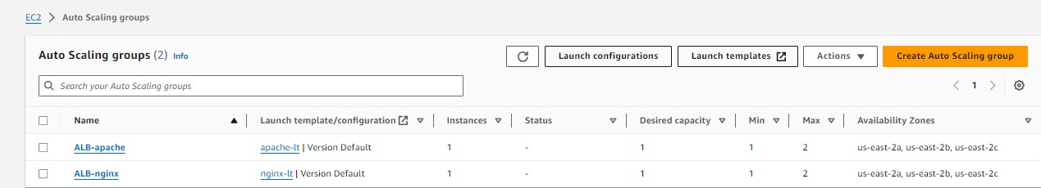

5.create a target group (nginx)
1.name------tg-nginx
2.type-------instance
3.path---------/
4.register-------nginx

6.create a target group (apache)
1.name------tg-apache
2.type-------instance
3.path---------/
4.register-------apache

7.create a load balancer
1.name-----------------ALB
2.default action-------tg-nginx
3.create a target group

9.click on created ALB
1.select listner------click on listner
2.action--------------edit listner
3.add target group-----tg-apache
4.add the weighted policy
1. tg-nginx---------7 --------------70%
2.tg-apache-------3 --------------30%
5.save the changes

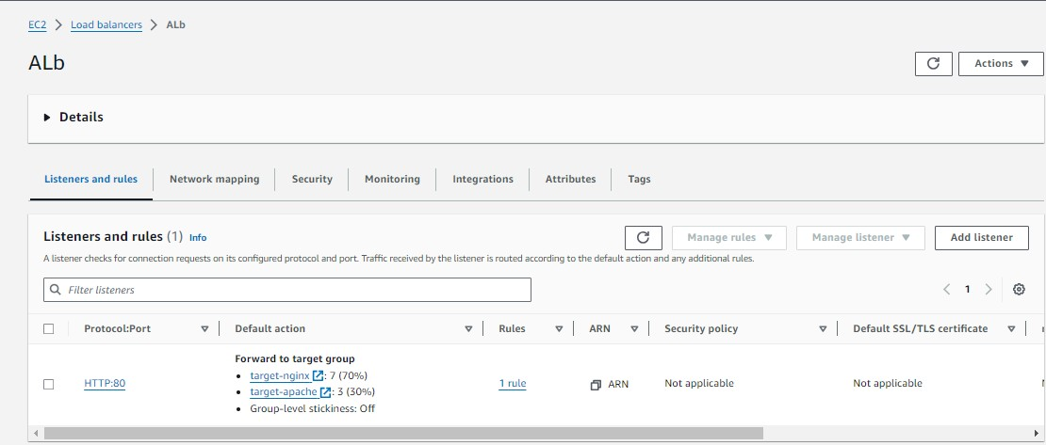

10.check the instances that we create
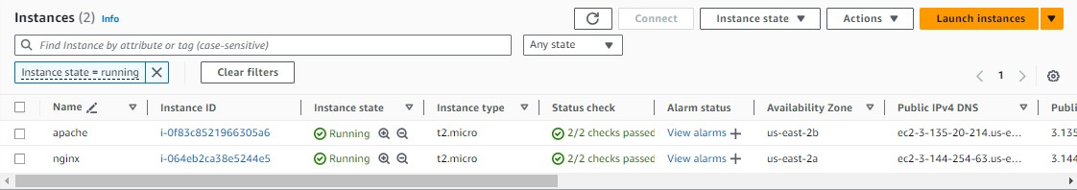

10.click on created instance – nginx---connect
1.sudo apt update -y
2.sudo apt install nginx -y
3.sudo systemctl start nginx

11.click on created instance apache----connect
1.sudo apt update -y
2.sudo apt install apache2 -y
Sudo systemctl start apache2

12.click on application load balancer that you created
1.copy the dns and paste

13.the traffic is moving on about 70% in nginx while in apache2 it should about 30%

===========================================================================

IMPLEMENT PEERING BETWEEN 4 VPC

1.create a vpc1-vpc2-vpc2 and vpc3

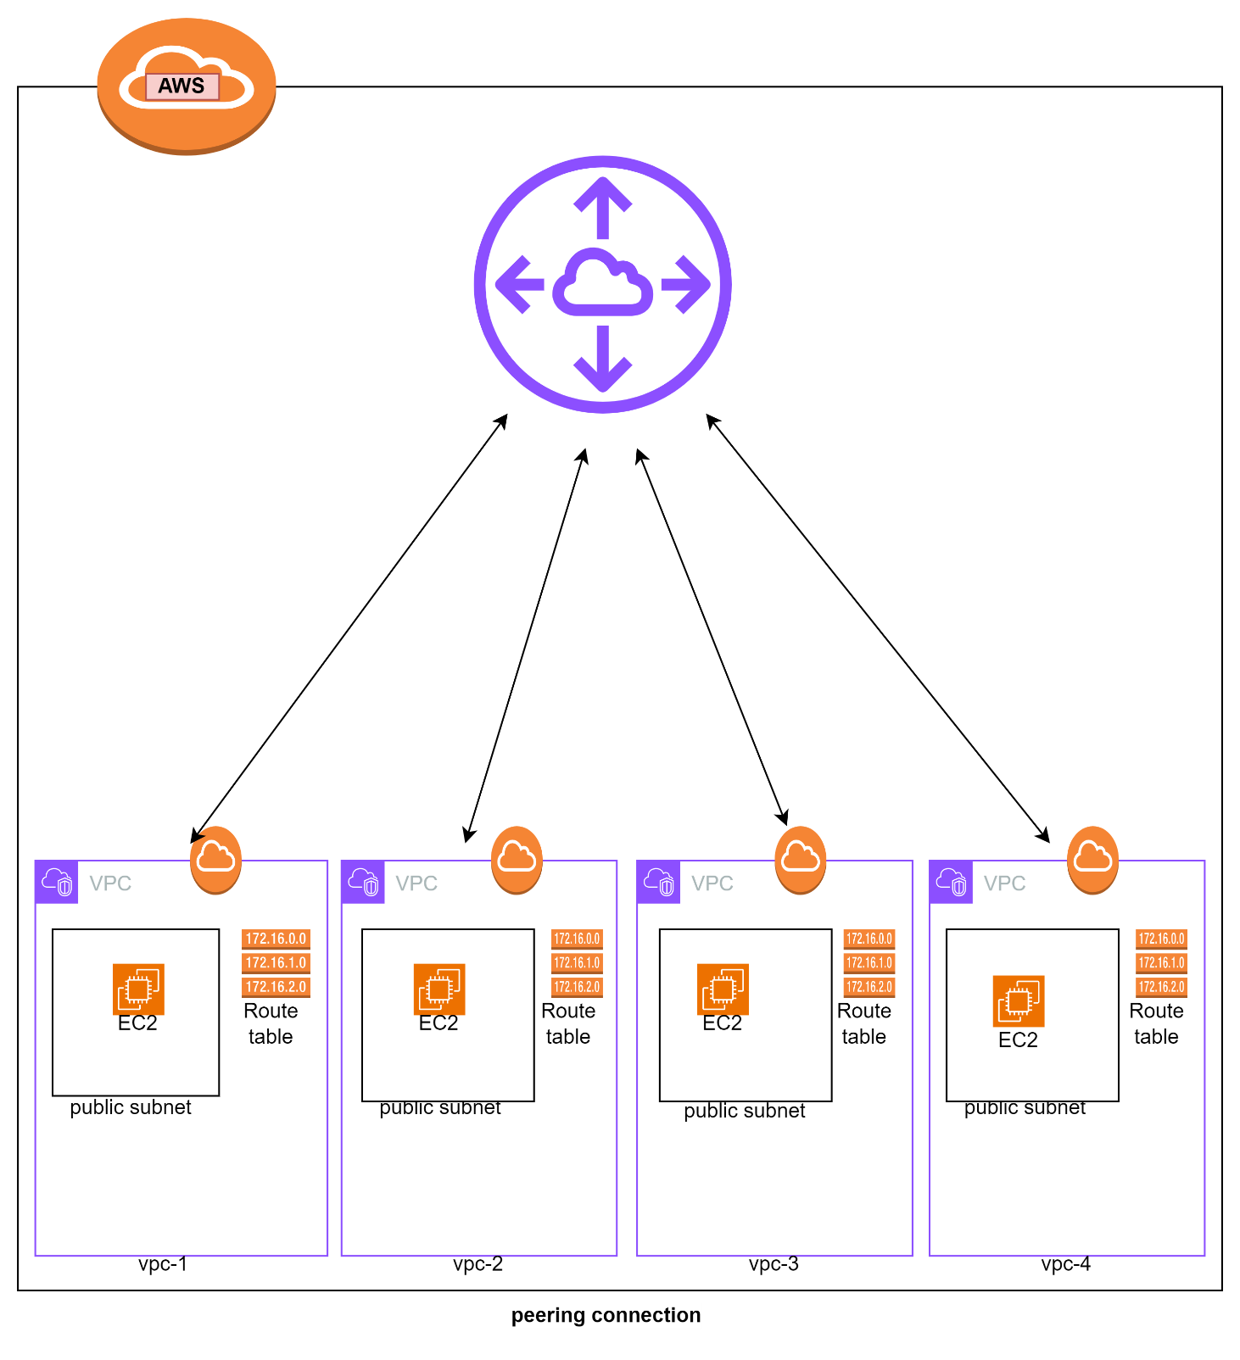
vpc1:-

1.create a vpc-1 -----------------------12.0.0.0/16
2.create a subnet--(subnet-vpc-1)-------12.0.1.0/24
3.create a IGW and attach to the vpc-1
4.create a route table--(rt-vpc-1)
associate---subnet-vpc-1----IGW
5.create a instance
1.name---------ec2-vpc-1
2.machine------amazon-linux
3.type---------t2.micro
4.key----------ec2-vpc-1 key
5.user-data
#!/bin/bash
sudo yum update -y
sudo yum install httpd -y
sudo systemctl start httpd.service
sudo echo "<h1> this is my 1st vpc </h1>" > /var/www/html/index.html
sudo systemctl restart httpd.service
sudo systemctl enable httpd.service

vpc2:-

1.create a vpc-2 -----------------------13.0.0.0/16
2.create a subnet--(subnet-vpc-2)-------13.0.1.0/24
3.create a IGW and attach to the vpc-2
4.create a route table--(rt-vpc-2)
associate---subnet-vpc-2----IGW
5.create a instance
1.name---------ec2-vpc-2
2.machine------amazon-linux
3.type---------t2.micro
4.key----------ec2-vpc-2 key
5.user-data
#!/bin/bash
sudo yum update -y
sudo yum install httpd -y
sudo systemctl start httpd.service
sudo echo "<h1> this is my 2nd vpc </h1>" > /var/www/html/index.html
sudo systemctl restart httpd.service
sudo systemctl enable httpd.service

vpc3:-

1.create a vpc-3 -----------------------14.0.0.0/16
2.create a subnet--(subnet-vpc-3)-------14.0.1.0/24
3.create a IGW and attach to the vpc-3
4.create a route table--(rt-vpc-3)
associate---subnet-vpc-3----IGW
5.create a instance
1.name---------ec2-vpc-3
2.machine------amazon-linux
3.type---------t2.micro
4.key----------ec2-vpc-3 key
5.user-data
#!/bin/bash
sudo yum update -y
sudo yum install httpd -y
sudo systemctl start httpd.service
sudo echo "<h1> this is my 3rd vpc </h1>" > /var/www/html/index.html
sudo systemctl restart httpd.service
sudo systemctl enable httpd.service

vpc4:-

1.create a vpc-4 -----------------------15.0.0.0/16
2.create a subnet--(subnet-vpc-4)-------15.0.1.0/24
3.create a IGW and attach to the vpc-4
4.create a route table--(rt-vpc-4)
associate---subnet-vpc-4----IGW
5.create a instance
1.name---------ec2-vpc-4
2.machine------amazon-linux
3.type---------t2.micro
4.key----------ec2-vpc-4 key
5.user-data
#!/bin/bash
sudo yum update -y
sudo yum install httpd -y
sudo systemctl start httpd.service
sudo echo "<h1> this is my 4th vpc </h1>" > /var/www/html/index.html
sudo systemctl restart httpd.service
sudo systemctl enable httpd.service

2.create a transit getway
1.name-------tg-for-vpc1-vpc2-vpc3-vpc4
2.create a transit getway

3.then create transit getway attachments-for-vpc-1
1.name----------tg-attachment-vpc-1
2.tg ID---------(select)
3.type----------vpc
4.vpc ID--------(vpc-1)
5.create a tg attachments

4.then create transit getway attachments-for-vpc-2
1.name----------tg-attachment-vpc-2
2.tg ID---------(select)
3.type----------vpc
4.vpc ID--------(vpc-2)
5.create a tg attachments

5.then create transit getway attachments-for-vpc-3
1.name----------tg-attachment-vpc-3
2.tg ID--------(select)
3.type---------vpc
4.vpc ID-------(vpc-3)
5.create a tg attachments

6.then create transit getway attachments-for-vpc-4
1.name----------tg-attachment-vpc-4
2.tg ID--------(select)
3.type---------vpc
4.vpc ID-------(vpc-4)
5.create a tg attachments

7.then updates the routs of vpc-1 in vpc-1 we can add (vpc2-vpc3-vpc4)
1.add route------13.0.0.0/16 ----------transit getway-------------save
2.add route------14.0.0.0/16-----------transit getway-------------save
3.add route------15.0.0.0/16-----------transit getway-------------save

8.then update the routs of vpc-2 in vpc-2 we can add (vpc1-vpc3-vpc4)
1.add route------12.0.0.0/16 ----------transit getway-------------save
2.add route------14.0.0.0/16-----------transit getway-------------save
3.add route------15.0.0.0/16-----------transit getway-------------save

9.then update the routs of vpc-3 in vpc-3 we can add (vpc1-vpc2-vpc4)
1.add route------12.0.0.0/16 ----------transit getway-------------save
2.add route------13.0.0.0/16-----------transit getway-------------save
3.add route------15.0.0.0/16-----------transit getway-------------save

10.then update the routs of vpc-4 in vpc-4 we can add (vpc1-vpc2-vpc3)
1.add route------12.0.0.0/16 ----------transit getway-------------save
2.add route------13.0.0.0/16-----------transit getway-------------save
3.add route------14.0.0.0/16-----------transit getway-------------save

11.then test the instances

12.instance----ec2-vpc-1----connect
1.vim vpc-1 key.pem
2.vim vpc-2 key.pem
3.vim vpc-3 key.pem
4.vim vpc-4 key.pem

chmod 400 vpc-1 key.pem
chmod 400 vpc-2 key.pem
chmod 400 vpc-3 key.pem
chmod 400 vpc-4 key.pem

1.ssh -i vpc-1 key.pem ubuntu@(ip of vpc-1)
curl (private ip of vpc-2)
curl (private ip of vpc-3)
curl (private ip of vpc-4)

===========================================================================

LOAD BALANCER WITH AUTOSCALING WITH THE RULE 40-40-20 WEIGHTED POLICY

1.create a template--nginx-tg
2.create a template--apache-tg
3.create a template—tomcat-tg
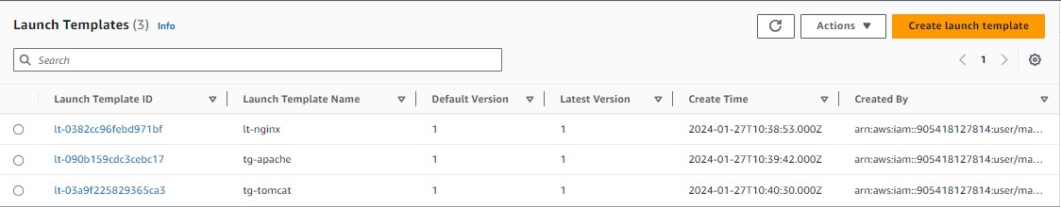

4.create a autoscaling group(nginx)
1.name ------ASG-nginx
2.template---nginx-lt
3.az and subnets----1a,1b,1c
4.capacity
desired-------1
minimum----1
maximum----2
5.add sns
6.tag---Name-nginx
7.create a autoscaling group

5.create a autoscaling group(apache)
1.name ------ASG-apache
2.template---apache-lt
3.az and subnets----1a,1b,1c
4.capacity
desired-------1
minimum----1
maximum----2
5.add sns
6.tag---Name-apache
7.create a autoscaling group

6.create a autoscaling group(tomcat)
1.name ------ASG-tomcat
2.template---tomcat-lt
3.az and subnets----1a,1b,1c
4.capacity
desired-------1
minimum----1
maximum----2
5.add sns
6.tag---Name-tomcat
7.create a autoscaling group

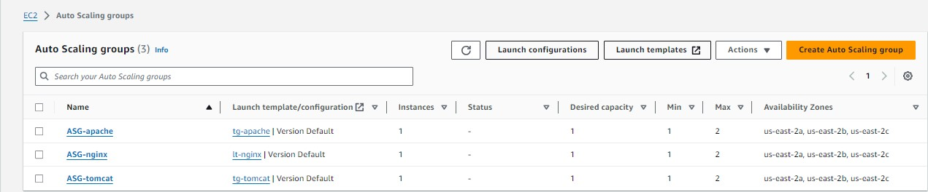

7.create a target group (nginx)
1.name------tg-nginx
2.type-------instance
3.path---------/
4.register-------nginx

8.create a target group (apache)
1.name------tg-apache
2.type-------instance
3.path---------/
4.register-------apache

9. create a target group (tomcat)
1.name------tg-tomcat
2.type-------instance
3.path---------/
4.register-------tomcat-----8080----include as pending below

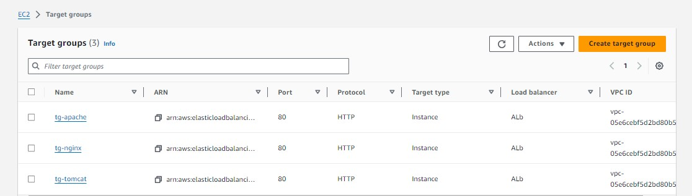

10.create a load balancer
1.name-----------------ALB
2.default action-------tg-nginx
3.create a target group

11.click on created ALB
1.select listner------click on listner
2.action--------------edit listner
3.add target group-----tg-apache and tg-tomcat
4.add the weighted policy
1. tg-nginx----------4---------------40%
2.tg-apache--------4 --------------40%
3.tg-tomcat---------2--------------20%

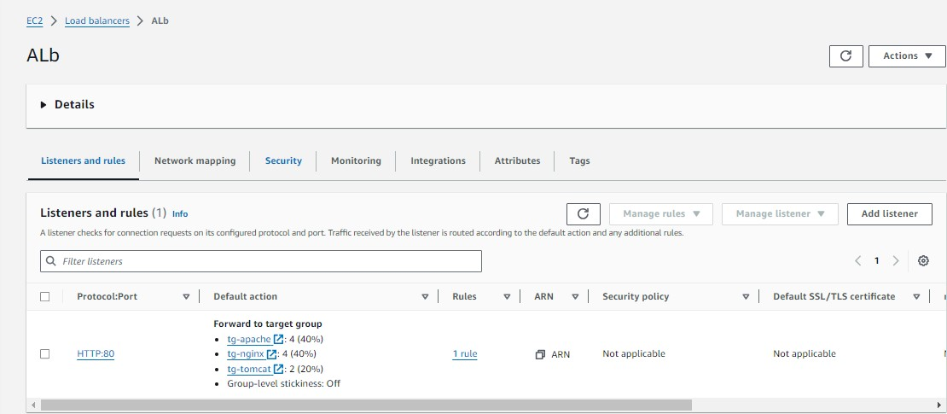
12.check the instances that we create

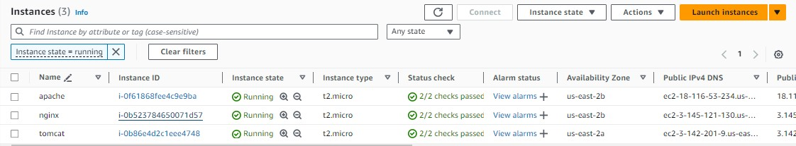

13.click on created instance – nginx---connect
1.sudo apt update -y
2.sudo apt install nginx -y
3.sudo systemctl start nginx

14.click on created instance--apache----connect
1.sudo apt update -y
2.sudo apt install apache2 -y
Sudo systemctl start apache2

15.click on created instance--tomcat---connect
1.sudo apt update -y
2.apt install java-openjdk-11 -y (apt install default-jre -y) / (apt install default-jdk -y)
3.wget https://dlcdn.apache.org/tomcat/tomcat-9/v9.0.85/bin/apache-tomcat-9.0.85.tar.gz
4.tar -xvf apache-tomcat-9.0.85.tar.gz
5.cd apache-tomcat-9.0.85
6.cd bin/
7. ./catalina.sh start

12.click on application load balancer that you created
1.copy the dns and paste

13.the traffic is on nginx 40%,apache 40% and in tomcat about 20%

===========================================================================

NGINX AS A LOAD BALANCER

1.create a instance [load balancer(server 1)
2.create a instance server 2
3.create a instance server 3
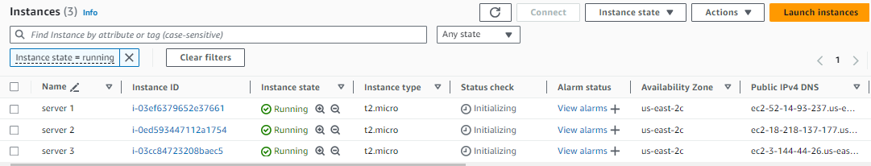

4.access the instance (server 2)
1.sudo apt udpate -y
2.sudo apt install nginx -y
3.sudo systemctl start nginx
4.sudo systemctl enable nginx
5.cd /var/www/html/
6.echo "HELLO" > index.html
7.sudo systemctl restart nginx
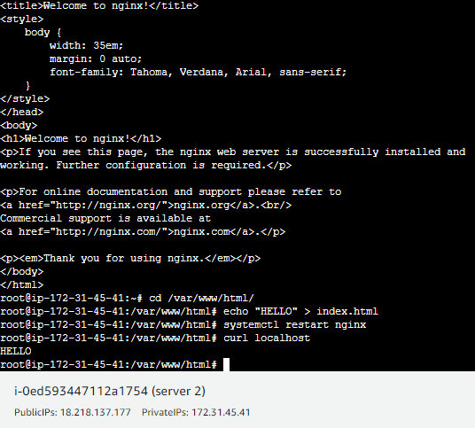
5.access the instance (server 3)
1.sudo apt udpate -y
2.sudo apt install nginx -y
3.sudo systemctl start nginx
4.sudo systemctl enable nginx
5.cd /var/www/html/
6.echo "hello cloudblitz" > index.html
7.sudo systemctl restart nginx
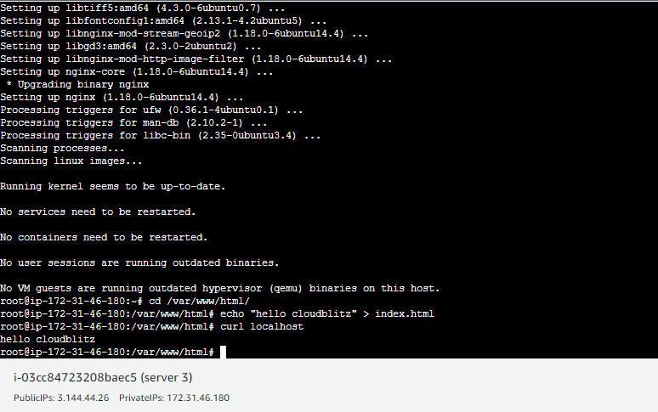

4.access the instance [load balancer(server 1)
1.sudo apt udpate -y
2.sudo apt install nginx -y
3.sudo systemctl start nginx
4.sudo systemctl enable nginx
5.then go to nginx conf file- vim /etc/nginx/nginx.conf
6.paste this in nginx.conf

events {
worker_connections 768;
}

http {
upstream myapp
{
server Server_1_Address weight=1;
server Server_2_Address weight=1;
}

#These are my settings SHROBON
server {
listen 80;
location / {
proxy_pass http://myapp ;
}
}
}

7. systemctl restart nginx
8. hit the loadbalancer ip in new tab

===========================================================================

CREATE A DATABASE (RDS)-AND CREATE TWO USERS

1.create a instance(rds)
1.name--------rds
2.machine-----amazon linux
3.type-----------t2.micro
4.sg--------------http/https/ssh/mysql-aurora(3306)
5.create a instance

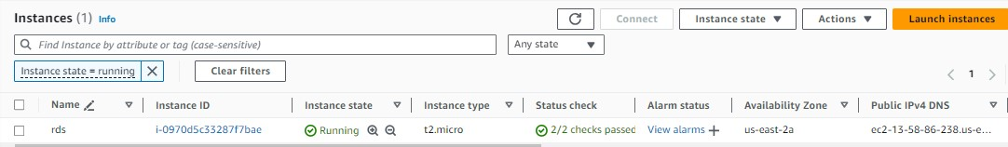

2.create a database (rds)
1.standard
2.engine-------------mariadb
3.tempalte-----------free tier
4.master username----admin
5.master password----admin123
6.connect to EC2 ----rds
7.existing vpc sg----(attach sg)
8.additional conf----student

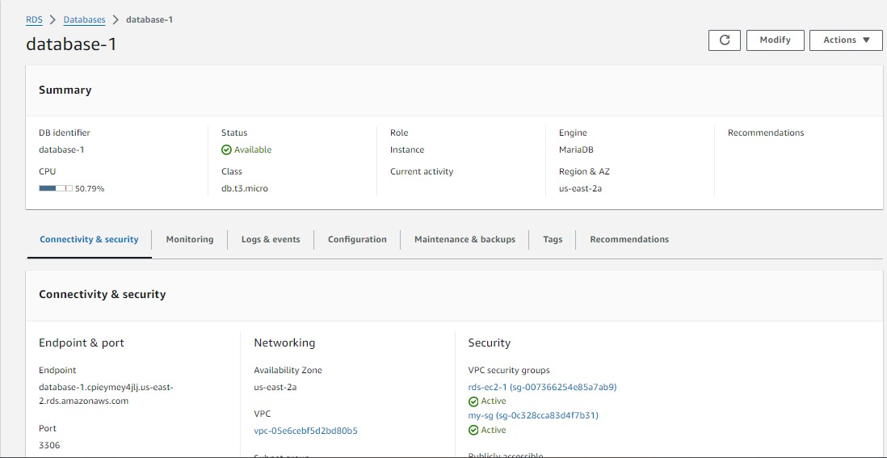

3.access the instance (rds)
1.yum install mariadb* -y
2.systemctl start mariadb
3.mysql -u admin -h (endpoint) -padmin123
1.create user santa identified by 'admin123';
2.create user banta identified by 'admin123';

3.GRANT ALL PRIVILEGES ON student.* TO 'santa';
4.ctrl+c

4. mysql -u santa -h (endpoint) -padmin123
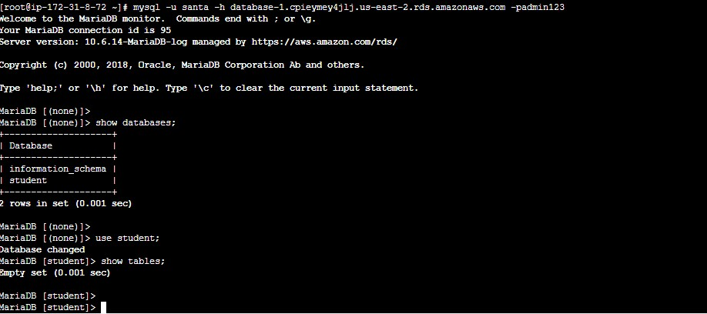

1.show databses;
2.use student;
1.create table student_info (serial_no int,student_name varchar(500),address
varchar(500),mobile_no bigint);
2.insert into student_info values (4,'shubham','palasgaon bai',7875863620);
3.insert into student_info values (2,'bhushan','palasgaon bai',7066329821);
4.insert into student_info values (3,'vaibhav','palasgaon bai',7378488213);
5.insert into student_info values (1,'mayur','palasgaon bai',7378644515);
6.insert into student_info values (5,'sameer', 'palasgaon bai',9090442312);
7.insert into student_info values (6,'swapnil', 'palasgaon bai',9090442312);
8.insert into student_info values (7,'nitin', 'palasgaon bai',7410529561);
9.insert into student_info values (8,'pranay', 'palasgaon bai',8208044715);
10.insert into student_info values (9,'paju', 'palasgaon bai',8080641694);
11.insert into student_info values (10,'rahul', 'palasgaon bai',8432339091);

3.select * from student_info;
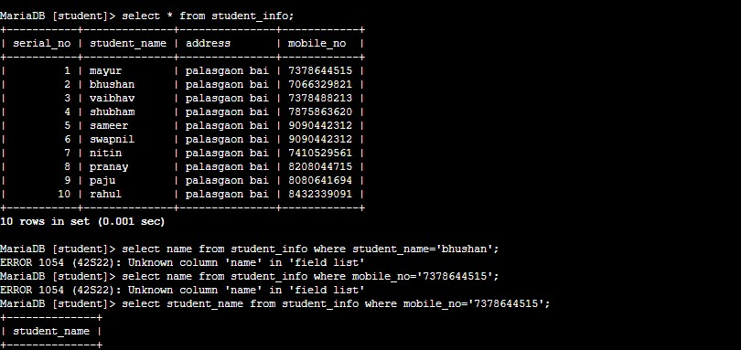
4.select student_name from student_info where mobile_no='7378644515';

S3 WITH CLOUDFRONT BUCKET SHOULD BE PRIVATE

1.download a css template

2.create a s3 bucket which is private
1.add these template in s3 bucket
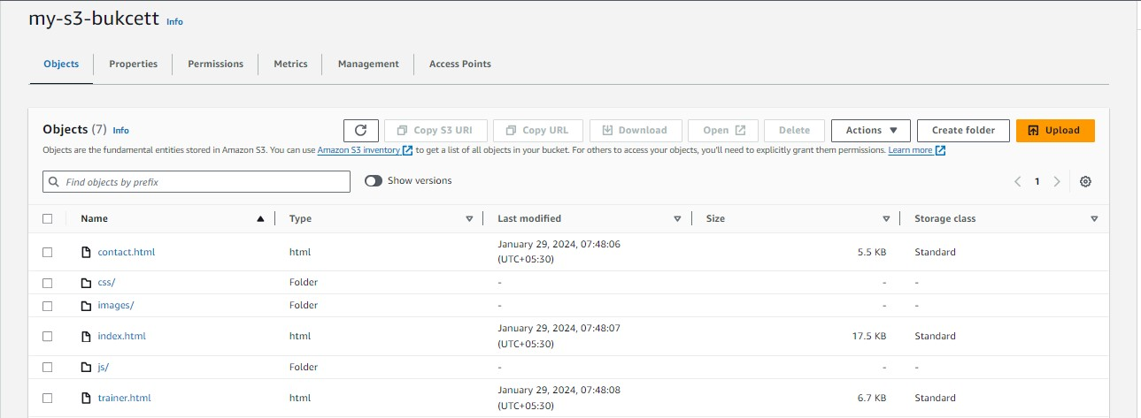

3.create a cloudfront
1.create a distribution
2.choose destination----s3 bucket
3.click on Origin access control settings------and create a control setting------create
4.create a distribution
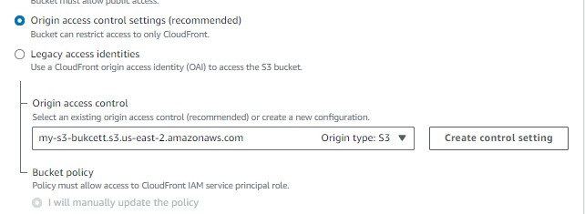

4.then you get a notification and copy these policy to s3 bucket
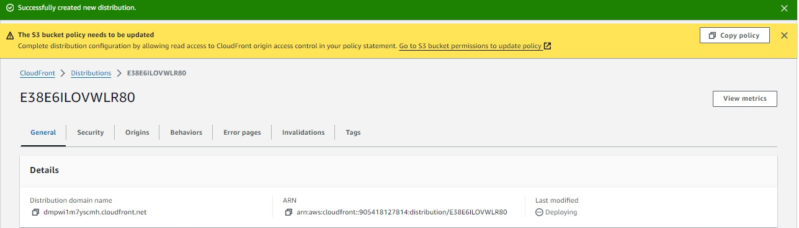

5.copy the dns and hit on web
{ (dns)/index.html }
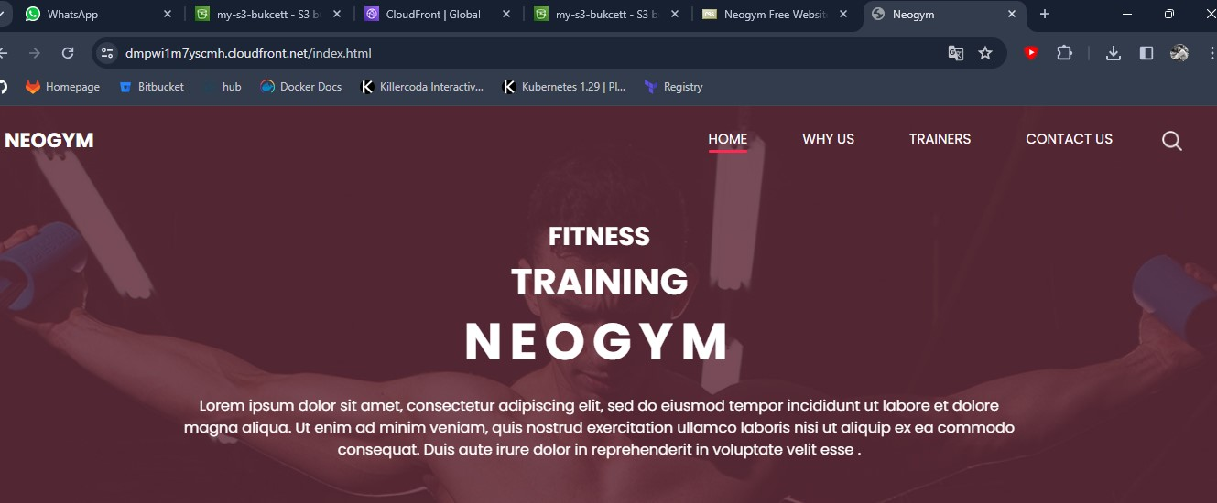

================================================================

Project-1
CREATE A DATABASE IN CENTOS 7 AND MIGRATE THESE DATABASE IN CLOUD

1.download a virtual box.
2.install a centos7 machine in virtual box.
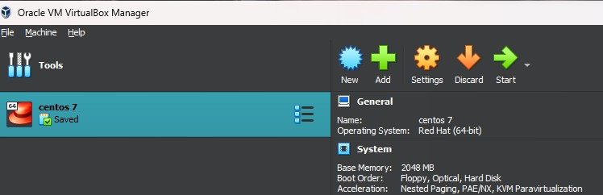
3.install mariadb on centos7
1.yum install mariadb-server -y
2.systemctl start mariadb,service

4.set the password
mysql_secure_installation

5.enter in mariadb
1.mysql -u root -h localhost -pmayur
1.show database;
2.create database student_data;
3.use student_data;
4.create table student_info (name varchar(10),roll_no int,status varchar(10));
5.show tables;
6.describe student_info;
7.insert into student_info values (‘user1’,100,’fail’);
insert into student_info values (‘user2’,101,’pass’);
insert into student_info values (‘user3’,102,’fail’);
insert into student_info values (‘user4’,103,’pass’);
insert into student_info values (‘user5’,104,’fail’);

8.select * from student_info;
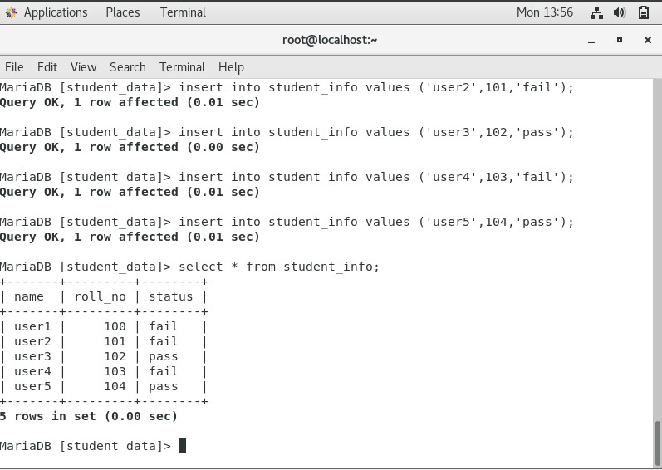
6.to create a backup
1.mysqldump -u root -h localhost -pmayur student_data >abc.bkp
2.cat abc.bkp

7.Then transfer these file in local machine. You can use scp either any command I am
using samba server to transfer these files in my local machine
1.install samba server in your centos7
1.yum install samba -y
2.mkdir /access
cp abc.bkp /access
3.useradd new
4.passwd new
5.vim /etc/samba/smb.conf
[access_dir]
path = /access
writable = yes
browseable = yes
Public = yes
Write list = new
Read list = new
Valid users = new
6.give directory permission to new user
Setfacl -m u:new:rwx /access
7.set samba password for new
Password: mayur
8.change selinux to permissive
Setenforce permissive
9.download samba-client
Yum install samba-client
Systemctl start smb
Systemctl start nmb
10.check we can access samba or not
smbclient -U new //localhost/access_dir
11.attach samba to windows----cross connectivity
1.go to network status
2.change adapter option
3.virtual box only adapter ---------------------------to see ip
192.168.56.1 -------------------------------------ip address
255.255.255.0 -----------------------------------netmask
4.In centos machine
1.add the adapter
-Host only adapter-
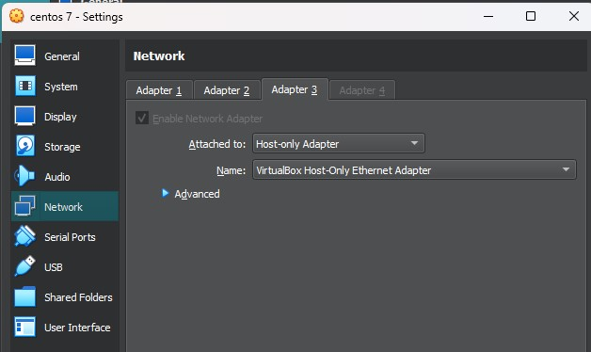
5.then in centos machine the the host-adapter ip that starts with 192
192.168.56.108
6.then ping these ip in window
192.168.56.108
7.and ping your local machine ip in centos
192.168.56.1
8.firewall-cmd --add-service=samba
9.then go to desktop
1.map network drive
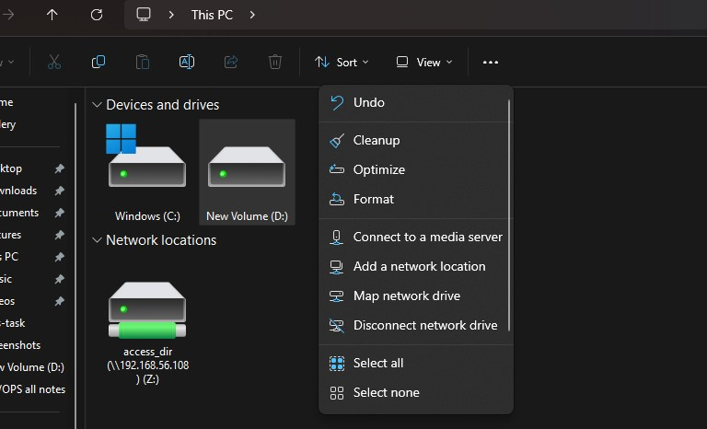
2.\\192.168.56.108\access
Give the username--------new
Password ------------------mayur
3.you can connect to the linux
1.then you can access all the files that are in access copy these abc.bkp file

8.create a s3 bucket and add abc.bkp file in s3 bucket
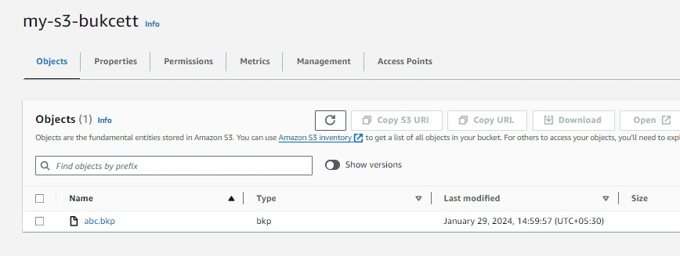
9.create a RDS(relational database)
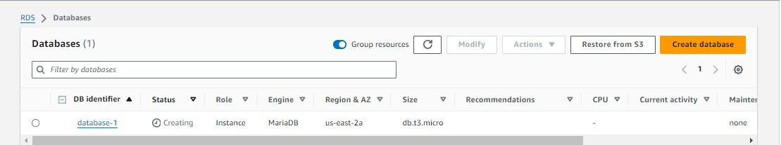
10.create a instance
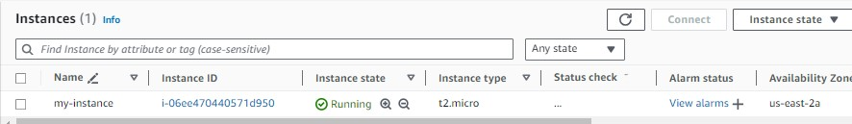

11.Then create a role that have s3 bucket full access and attach to the instance
12.access the instance
1.aws s3 ls
3.aws s3 ls s3://my-s3-bucket
3.aws s3 cp s3://my-s3-bucket/abc.bkp /root
4.ls
abc.bkp
13.Then install mariadb in server
1.Yum install mariadb -y
2.Systemctl start mariadb.service
14.Retrive these backup in rds
1.mysql -u admin -h (endpoint) -padmin123 student_data <abc.bkp
15.Then check the database
1.mysql -u admin -h(endpoint) -padmin123
1.show database;
2.use student_data;
3.describe student_info;
4.select * from student_info;
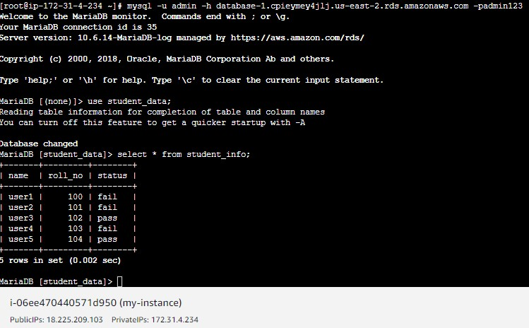

PROJECT:-2
Migrate on premises virtual machine on cloud

1.set up tomcat on virtual machine(ubuntu)
1.sudo apt upgrade -y
1.apt install openjdk-11-jdk -y
2.wget https://dlcdn.apache.org/tomcat/tomcat-9/v9.0.85/bin/apache-tomcat-
9.0.85.tar.gz
3.tar -xvf apache-tomcat-9.0.85.tar.gz
4.rm -rf apache-tomcat-9.0.85.tar.gz
5.cd apache-tomcat-9.0.85
6.cd bin/
7. ./Catalina.sh start
8.cd
9.firewall-cmd –add-port=8080/tcp
10.curl localhost:8080

2.set up nginx on virtual machine
1.apt update -y
2.apt install epel-release -y
3.apt install nginx -y
4.systemctl start nginx
5.systemctl enable nginx
6.vim /etc/nginx/sites-available/default
server {
listen 80;
server_name localhost;

location / {
proxy_pass http://localhost:8080;
proxy_set_header Host $host;
proxy_set_header X-Real-IP $remote_addr;
proxy_set_header X-Forwarded-For $proxy_add_x_forwarded_for;
proxy_set_header X-Forwarded-Proto $scheme;
}

# Additional Nginx configurations if needed
}

7.systemctl restart nginx
8.curl localhost
You get tomcat
##if u get any error while u edit nginx file run the command----{nginx -t} u will get the error
3.then export your machine
1.go to machine(virtual box)
2.click on export appliance
3.give the extension (ovf)(ova)
4.then go to folder and check properly export or not
5.then create s3 bucket (my-s3-bucket)
1.add ubuntu.ova file to s3-bucket
6.create a access key and secret key for your aws cli in windows to configure
7.create a IAM role name “vmimport”
1.create a file trust-policy.json in your desktop(text file)
{
"Version": "2012-10-17",
"Statement": [
{
"Effect": "Allow",
"Principal": { "Service": "vmie.amazonaws.com" },
"Action": "sts:AssumeRole",
"Condition": {
"StringEquals":{
"sts:Externalid": "vmimport"
}
}
}
]
}
2.go to cmd…configure and create these role
aws iam create-role --role-name vmimport --assume-role-policy-document
file://trust-policy.json
note:- if u save these file in desktop then you can also work on these directory
otherwise you can get the full path of these file

8.create another file name role-policy.json
{
"Version":"2012-10-17",
"Statement":[
{
"Effect": "Allow",
"Action": [
"s3:GetBucketLocation",
"s3:GetObject",
"s3:ListBucket"
],
"Resource": [
"arn:aws:s3:::my-s3-bucket",
"arn:aws:s3:::my-s3-bucket/*"
]
},
{
"Effect": "Allow",
"Action": [
"s3:GetBucketLocation",
"s3:GetObject",
"s3:ListBucket",
"s3:PutObject",
"s3:GetBucketAcl"
],
"Resource": [
"arn:aws:s3:::my-s3-bucket",
"arn:aws:s3:::my-s3-bucket/*"
]
},
{
"Effect": "Allow",
"Action": [
"ec2:ModifySnapshotAttribute",
"ec2:CopySnapshot",
"ec2:RegisterImage",
"ec2:Describe*"
],
"Resource": "*"
}
]
}

2.create a policy for these role
aws iam put-role-policy --role-name vmimport --policy-name vmimport --policy-document
file://role-policy.json

9.you can also move these exported file with command
aws s3 mv "/home/administrator/Documents/ubuntu.ova" s3://my-s3-bucket
note:- change the bucket name as well as change the path for your exported file

10. Import the VM image to AWS AMI
1. After you upload your VM image file to Amazon S3, you can use the AWS CLI to
import the image.
2. Create another file named containers.json with the following policy.

[
{
"Description": "My Server OVA",
"Format": "ova",
"UserBucket": {
"S3Bucket": "my-s3-bucket",
"S3Key": "ubuntu.ova"
}
}
]

NOTE:- you can change the file format as well as bucket name also change the key name
Your key name is your uploaded file name

3.then run the command to import image
aws ec2 import-image --description "My On-Premise Centos vm" --disk-containers
file://containers.json

** after importing you will get output like these**

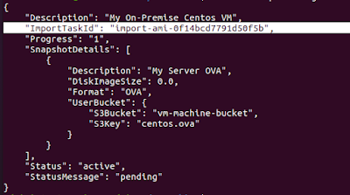

11.monitor images import task
**Note: Replace "import-ami-1234567890abcdef0" from above output ImportTaskId**
Run these command to check the status
aws ec2 describe-import-image-tasks --import-task-ids import-ami-0f14bcd7791d50f5b

**Status values include the following**
active — The import task is in progress.
deleting — The import task is being canceled.
deleted — The import task is canceled.
updating — Import status is updating.
validating — The imported image is being validated.
validated — The imported image was validated.
converting — The imported image is being converted into an AMI.
completed — The import task is completed and the AMI is ready to use
NOTE:- after get status of completed you can check the ami

12. After Completed import image task, Let's check AMI section
13. The ami image is seen you can Launch EC2 Instance through that AMI
14.then launch the EC2 with these image
15.and when u configured u gave the credentials of your ubuntu machine
16.curl {localhost}
17.curl {public_ip}

Simplified steps of migrating on-premises vm to cloud

1.1st set up the virtual machine where the tomcat request should be move on localhost rather than localhost:8080 by reverse proxy
2.then export the virtual machine in local
3.create a s3 bucket and upload these file manual to the s3 bucket you can also upload by command line through cmd
4.create the credentials {access key and secret key } for the cmd so we can work on the cmd
5.create a role only i.e vmimport
1.create a policy.json for the role so that role can access the aws services
2.also create a role-policy.json for the role that have the permissions of s3 bucket like put get etc
6.attach these policy to the role
7.then run the command for import of vm to aws ami
8.check the ami section
9.with the help of these ami create a virtual machine and configure
10.1st time when u configured you get the credential of your vm that you gave when set up the ubuntu in virtual box

BLUE GREEN DEPLOYMENT
----Blue Green Deployment----

Step.1 -first we will launch two instance with different name like blue and green.
for Blue-instance:(this is our live environment which run on old version)
1. sudo -i (for root user access)
2. yum install nginx -y
3. echo “<h1> This is my blue environment </h1>” >/usr/share/nginx/html/index.html
4. systemctl restart nginx
5.systemctl enable nginx
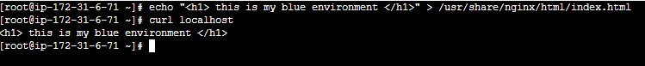

For Green-instance:(this is our green environment which run on new or update version)
1. sudo -i (for root user access)
2. yum install nginx -y
3. echo “<h1> This is green environment </h1>” > /usr/share/nginx/html/index.html 4. systemctl restart nginx
5.systemctl enable nginx
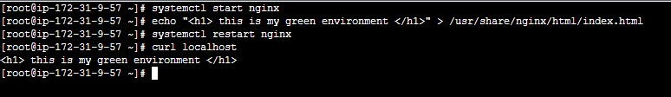

Step.2 create Two target group
1. blue-tg: blue-instance will register on this tg.
2. green-tg: green-instance will register on this tg.
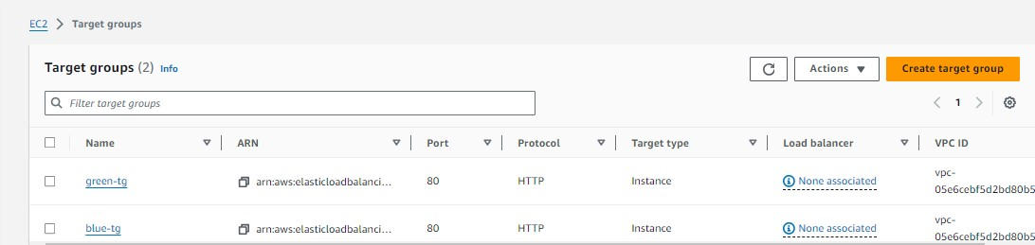

Step.3 Create an application load balancer
1.first we will add blue-tg on load balancer. and now 100% traffic will come on blue-
tg and load balancer distribute this traffic to its registered instance.
2.now we will add green-tg which is updated and deploy it with load balancer listener
where i have already a listener on this load balancer
3.go to listener and rules and click on listener port and then go to action and click on
edit listener rule scroll down and here is already blue-tg now click on add target
group add green tg with 20% weight and blue-tg with 80% weighsave changes
4.now hit the load balancer. And see 80% traffic routed on blue while 20% on green
5.if our green environment working good and have no other issue on this enviromnet
we will swicth the all traffic with this green enviromnet.
6.These environment little bit costly because we have already create the servers to
Test The load
